Lab 9 Heap

Q1.
Illustrate the operation of Max_Heapify(A, 3) using the array

Q2.
Show the operation of Build-Heap using the array below:

Q3. Illustrate the operation of Heapsort using the array below:

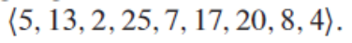

Q4. Show that in an n-element heap, there are at most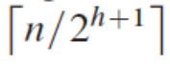 nodes of height h.

